**Bubble sort algorithm in C#**

Name of student

Name of professor

University

Course

Date

Introduction

The bubble sort algorithm basically is the computers way of solving or arriving at a solution within the given shorted period possible. The algorithm basically looks at the problem and tries to swap the items in order until the objects are sorted as required.

In this context, we shall consider a random list of integers as follows:

15428.

We shall try to use bubble sort to solve this problem as follows:

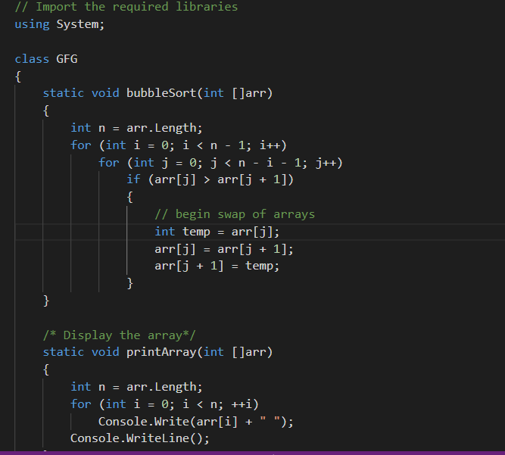

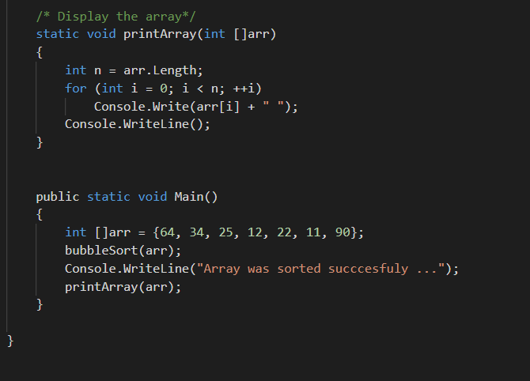

The sorted array will be printed as below:

 //Resulting output

// 11 12 22 25 34 64 90

And the graph illustration for this is as below:

